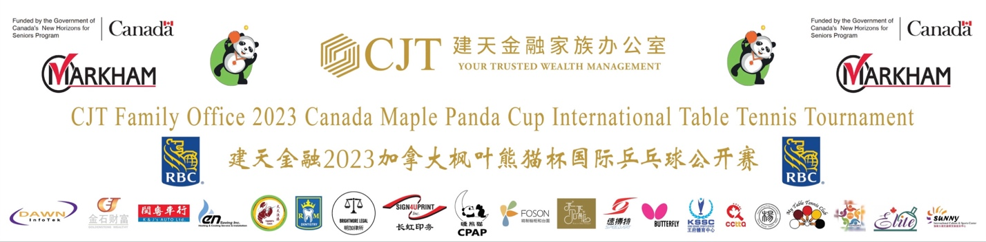

CJT Family Office 2023-2024 Canada Maple Panda Cup International Table Tennis Tournament

Tournament Arbitration Committee
Regulations:
The Tournament Arbitration Committee is responsible for handling disputes and controversies arising in table tennis matches. Its primary functions include:
A. Adjudicating Disputes: The committee's main responsibility is to adjudicate disputes and controversies related to table tennis matches. This may involve athletes, coaches, referees, or other relevant parties, such as the interpretation of match rules and handling of rule violations.
B. Ensuring Fair Play: The committee is tasked with ensuring the fairness and impartiality of the matches. They may address complaints regarding rule violations, cheating, improper referee decisions, and take appropriate measures to safeguard the fairness of the competition.
C. Rule Interpretation: The committee is responsible for interpreting and applying the rules of table tennis matches. This may include providing specific interpretations of the rules to make reasonable rulings in particular situations.
D. Mediation: The committee may participate in mediating disputes between parties, attempting to reach solutions acceptable to both sides through negotiation and preventing the escalation of conflicts.
E. Arbitration Procedures/Appeals Process: Teams wishing to appeal must submit their appeal in writing, via SMS, email, etc., to the Arbitration Committee. The Committee will provide a final decision within 10 minutes, and this decision will be final decision and with no further right to appeal.
F. Equipment Compliance: Athletes' playing equipment must adhere to ITTF international standards. The Arbitration Committee and referees have the authority to inspect equipment. Non-compliant equipment will be required to be replaced, or match results may be canceled.
Overall, the goal of the Tournament Arbitration Committee for this event is to ensure the fair and just conduct of the matches while effectively resolving disputes and controversies related to table tennis competitions.
Tournament Arbitration Committee:
- Mark Bu (Chair): International Umpire, White Badge Umpire
- Lei Zhang: Founder of Canada Maple Panda Cup, former Chinese national table tennis team player, served at ITTF, Table Tennis Canada, and Ontario Table Tennis Association
- Nancy Yan: International Umpire, Blue Badge Umpire in Progress, National Referee
Date: November 15, 2023 Panda Cup Organizing Committee

